Financial Status

CFMA Bluyeama – Sing Africa

Sofreco final report

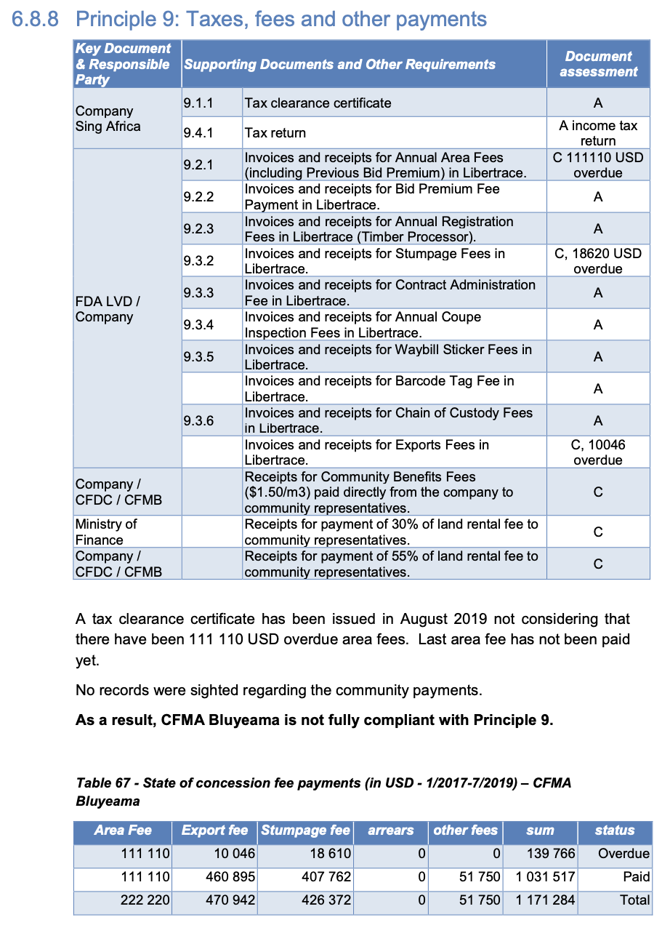

Libertrace – most recent data (May 2022)
Invoiced – $78,138.93for May 2022 [$76,638.93 stumpage {unpaid} & $1,500 other fees* {paid}]
Paid – $1,500
Balance Due – $76,638.93

*Waybill sticker [p.31]

LEITI – most recent data (2019)
Payments FY19 – $430,032
On production of 5,713 m³
Exports $109,328

Land rental arrears (2019) – Forest Trends report
No mention

https://libertrace.sgs.com Monthly Performance Report May 2022
https://www.leiti.org.lr/sites/default/files/documents/LEITI%2013th%20Report%20final.pdf 13th REPORT 2019 - 2020
https://www.forest-trends.org/publications/community-benefits-sharing-in-the-forestry-sector-liberias-legislative-framework-track-record-on-sharing-land-rental-fees-from-commercial-forestry-2007-2019/

