Financial Status

CFMA Sewacajua -- Mandra

Sofreco final report

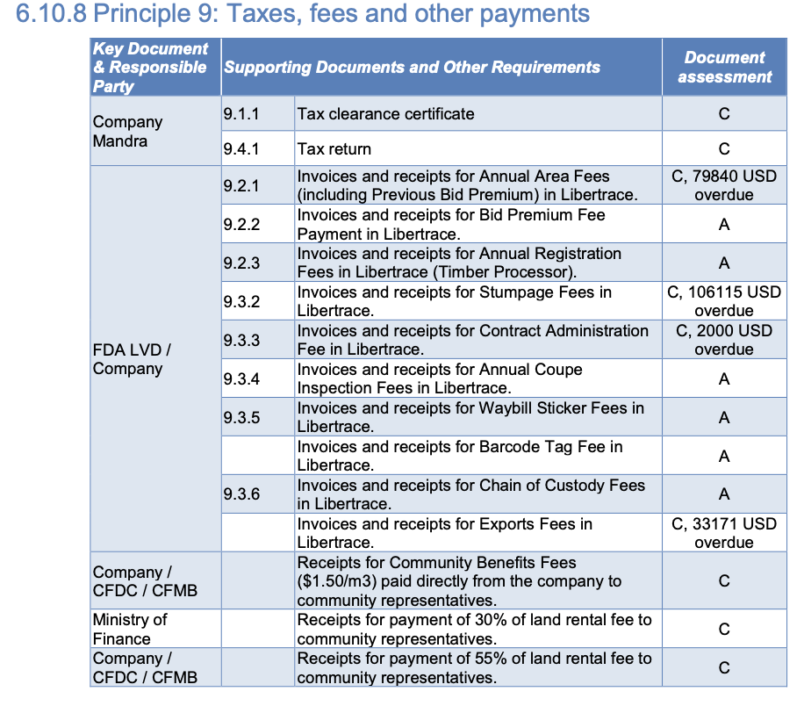
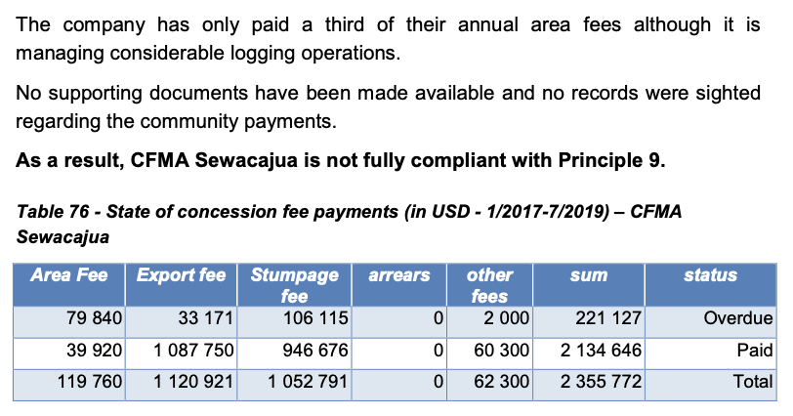

Libertrace – most recent data (May 2022)
Invoiced – $126,178.05 [$66,692.63 stumpage & $40,521.42 export fees & $40,521.42 other fees]
Paid – $0
Balance Due – $126,178.05

Despite exports of 5,048.367 m³ on 704 log tags [p.11]

LEITI – most recent data (2019)
Payments FY19 – $1,595,172; $1,464,652 to LRA and $130,520 to NPA
On exports of 45,517 m³ worth $881,022 [p.69 & 118]
“Mandra Forestry is the lead exporter of round logs (21.9%)” [p10]
“Per FDA, the forest sector production 87,996.7 m3 of round logs in FY 2019/2020. Of this amount, Mandra Forestry Liberia 5 entities (Mandra Forestry Liberia Ltd, 21.5%” [p.67]

Land rental arrears (2019) – Forest Trends report
--- listed as Mandra/LTTC (may not be for CFMA Sewacajua)
Payments to 2017 – $9.6 million
Arrears (FY17) – none noted
Land area fee arrears (Jan 2019) – $0.7 million

https://libertrace.sgs.com Monthly Performance Report May 2022
https://www.leiti.org.lr/sites/default/files/documents/LEITI%2013th%20Report%20final.pdf 13th REPORT 2019 - 2020
https://www.forest-trends.org/publications/community-benefits-sharing-in-the-forestry-sector-liberias-legislative-framework-track-record-on-sharing-land-rental-fees-from-commercial-forestry-2007-2019/

