Financial Status

FMC K -- ICC

Sofreco final report
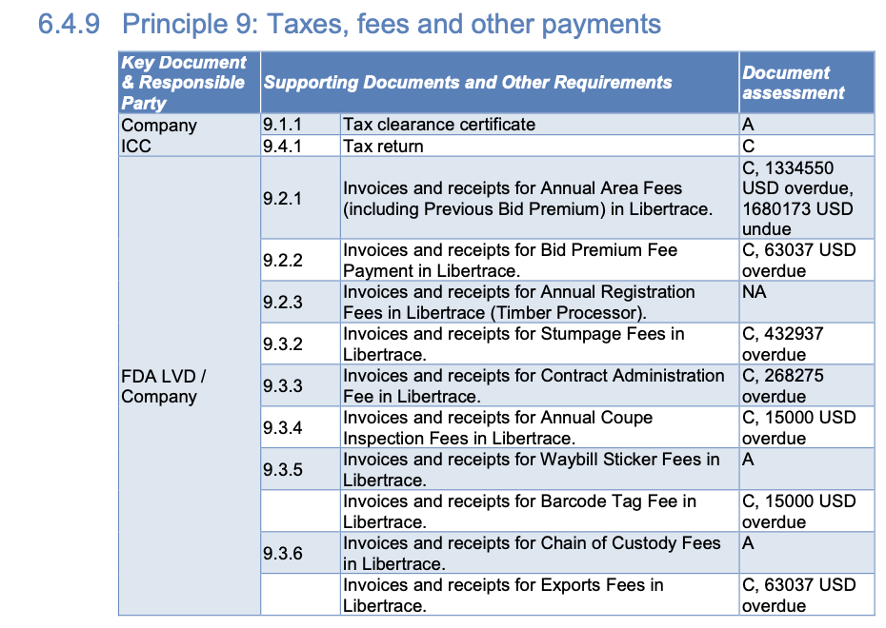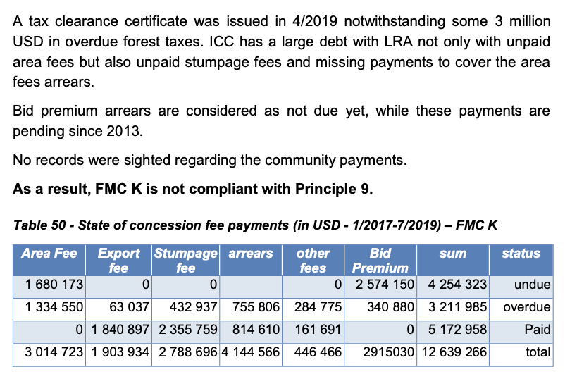

Libertrace – most recent data (May 2022)
No mention

LEITI – most recent data (2019)
Payments FY19 – $865,557

Land rental arrears (2019) – Forest Trends report
Payments to 2017 – $14.8 million
Arrears (FY17) – $7 million
Land area fee arrears (Jan 2019) – $1.9 million

https://libertrace.sgs.com Monthly Performance Report May 2022
https://www.leiti.org.lr/sites/default/files/documents/LEITI%2013th%20Report%20final.pdf 13th REPORT 2019 - 2020
https://www.forest-trends.org/publications/community-benefits-sharing-in-the-forestry-sector-liberias-legislative-framework-track-record-on-sharing-land-rental-fees-from-commercial-forestry-2007-2019/

